***Requirements Engineering Processes***

***Lecture 7***

***Recap of Last Lecture***

* We introduced the concept of requirements engineering process
* We discussed inputs and outputs of the requirements engineering process
* We introduced high-level activities in the requirements engineering process
  + Requirements elicitation
  + Requirements analysis and negotiation
  + Requirements specification
  + Requirements validation
  + Requirements management

***Today’s Topics***

* Actors and stakeholders in the requirements engineering process
* Process and process improvement for requirements engineering

***Who are Actors?***

* Actors in a process are the people involved in the execution of that process
* Actors are normally identified by their roles rather than individually, e.g., project manager, purchasing director, and system engineer

***Actors in the RE Process***

* Requirements engineering involves people who are primarily interested in the problem to be solved (end-users, etc.) as well as people interested in the solution (system designers, etc.)
* Another group of people, such as health & safety regulators, and maintenance engineers may be affected by the existence of the system
* Role-action diagrams are process models which show the actors associated with different process activities
* They document the information needs of different people involved in the process
* They use model of prototype software system as part of requirements elicitation process

***Role-Action Diagram for Software Prototyping***

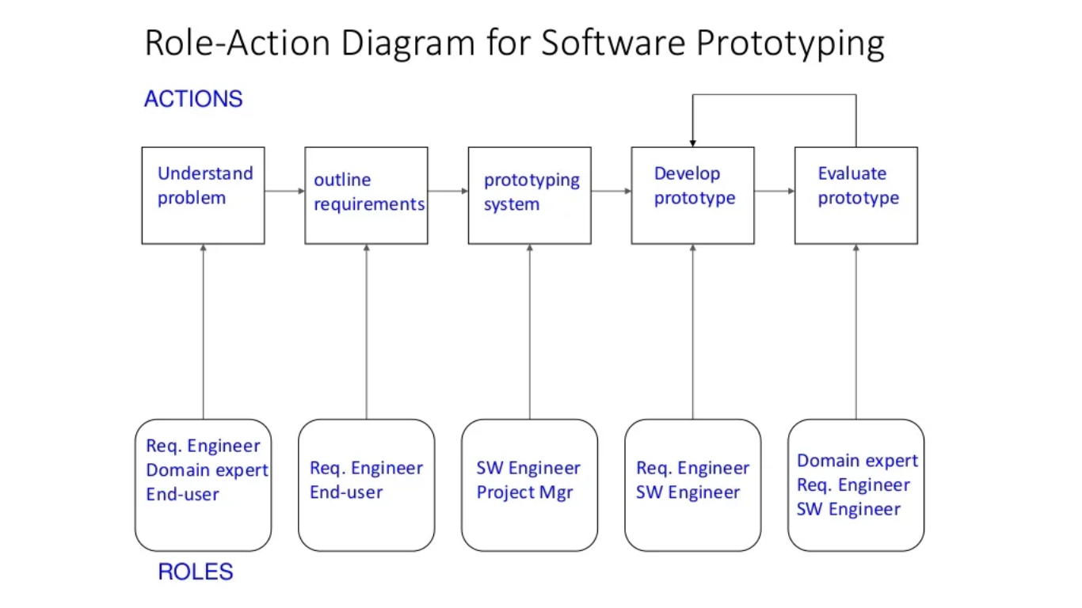

***Role Descriptions***

|  |  |
| --- | --- |
| **Role** | **Description** |
| Domain Expert | Responsible for proving information about the application domain and the specific problem in that domain, which is to be solved |
| System End-user | Responsible for using the system after delivery |
| Requirements Engineer | Responsible for eliciting and specifying the system requirements |
| Software Engineer | Responsible for developing the prototype software system |
| Project Manager | Responsible for planning and estimating the prototyping project |

***Human and Social Factors***

* Requirements engineering processes are dominated by human, social and organizational factors because they always involve a range of stakeholders from different backgrounds and with different individual and organizational goals
* System stakeholders may come from a range of technical and non-technical background and from different disciplines

***Stakeholder Types***

* Software engineers
* System end-users
* Managers of system end-users
* External regulators
* Domain experts

***Factors Influencing Requirements***

* Personality and status of stakeholders
* The personal goals of individuals within an organization
* The degree of political influence of stakeholders within an organization

***Process Support***

* One way to minimize errors in the requirements engineering is to use process models and to use CASE tools
* The most mature CASE tools support well-understood activities such as programming and testing and the use of structured methods
* Support for requirements engineering is still limited because of the informality and the variability of the process

***CASE Tools for RE***

* Modeling and validation tools support the development of system models which can be used to specify the system and the checking of these models for completeness and consistency
* Management tools help manage a database of requirements and support the management of changes to these requirements

***Process Improvement***

* Process improvement is concerned with modifying processes in order to meet some improvement objectives
* Improvement objectives
* **Quality improvement**
* **Schedule reduction**
* **Resource reduction**

***Planning Process Improvement***

* **Some important questions arise:**
* What are the problems with current processes?
* What are the improvement goals?
* How can process improvement be introduced to achieve these goals?
* How should process improvements be controlled and managed?

***RE Process Problems***

* Lack of stakeholder involvement
* Business needs not considered
* Lack of requirements management
* Lack of defined responsibilities
* Stakeholder communication problems
* Over-long schedules and poor-quality requirements documents

***Process Maturity***

* Process maturity can be thought of as the extent that an organization has defined its processes, actively controlled these processes and provided systematic human and computer-based support for them
* The SEI’s Capability Maturity Model is a framework for assessing software process maturity in development organizations

***Capability Maturity Model***

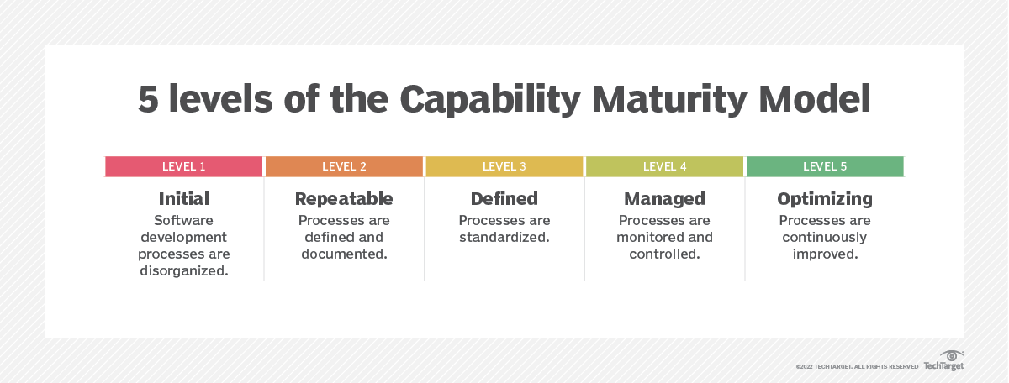

***CMM Level 1: Initial***

* Organizations have an undisciplined process and it is left to individuals that how to manage the process and which development techniques to use

***CMM Level 2: Repeatable***

* Organizations have basic cost and schedule management procedures in place. They are likely to be able to make consistent budget and schedule predictions for projects in the same application area

***CMM Level 3: Defined***

* The software process for both management and engineering activities is documented, standardized and integrated into a standard software process for the organization

***CMM Level 4: Managed***

* Detailed measurements of both process and product quality are collected and used to control the process

***CMM Level 5: Optimizing***

* The organization has a continuous process improvement strategy, based on objective measurements, in place

***RE Process Maturity Model***

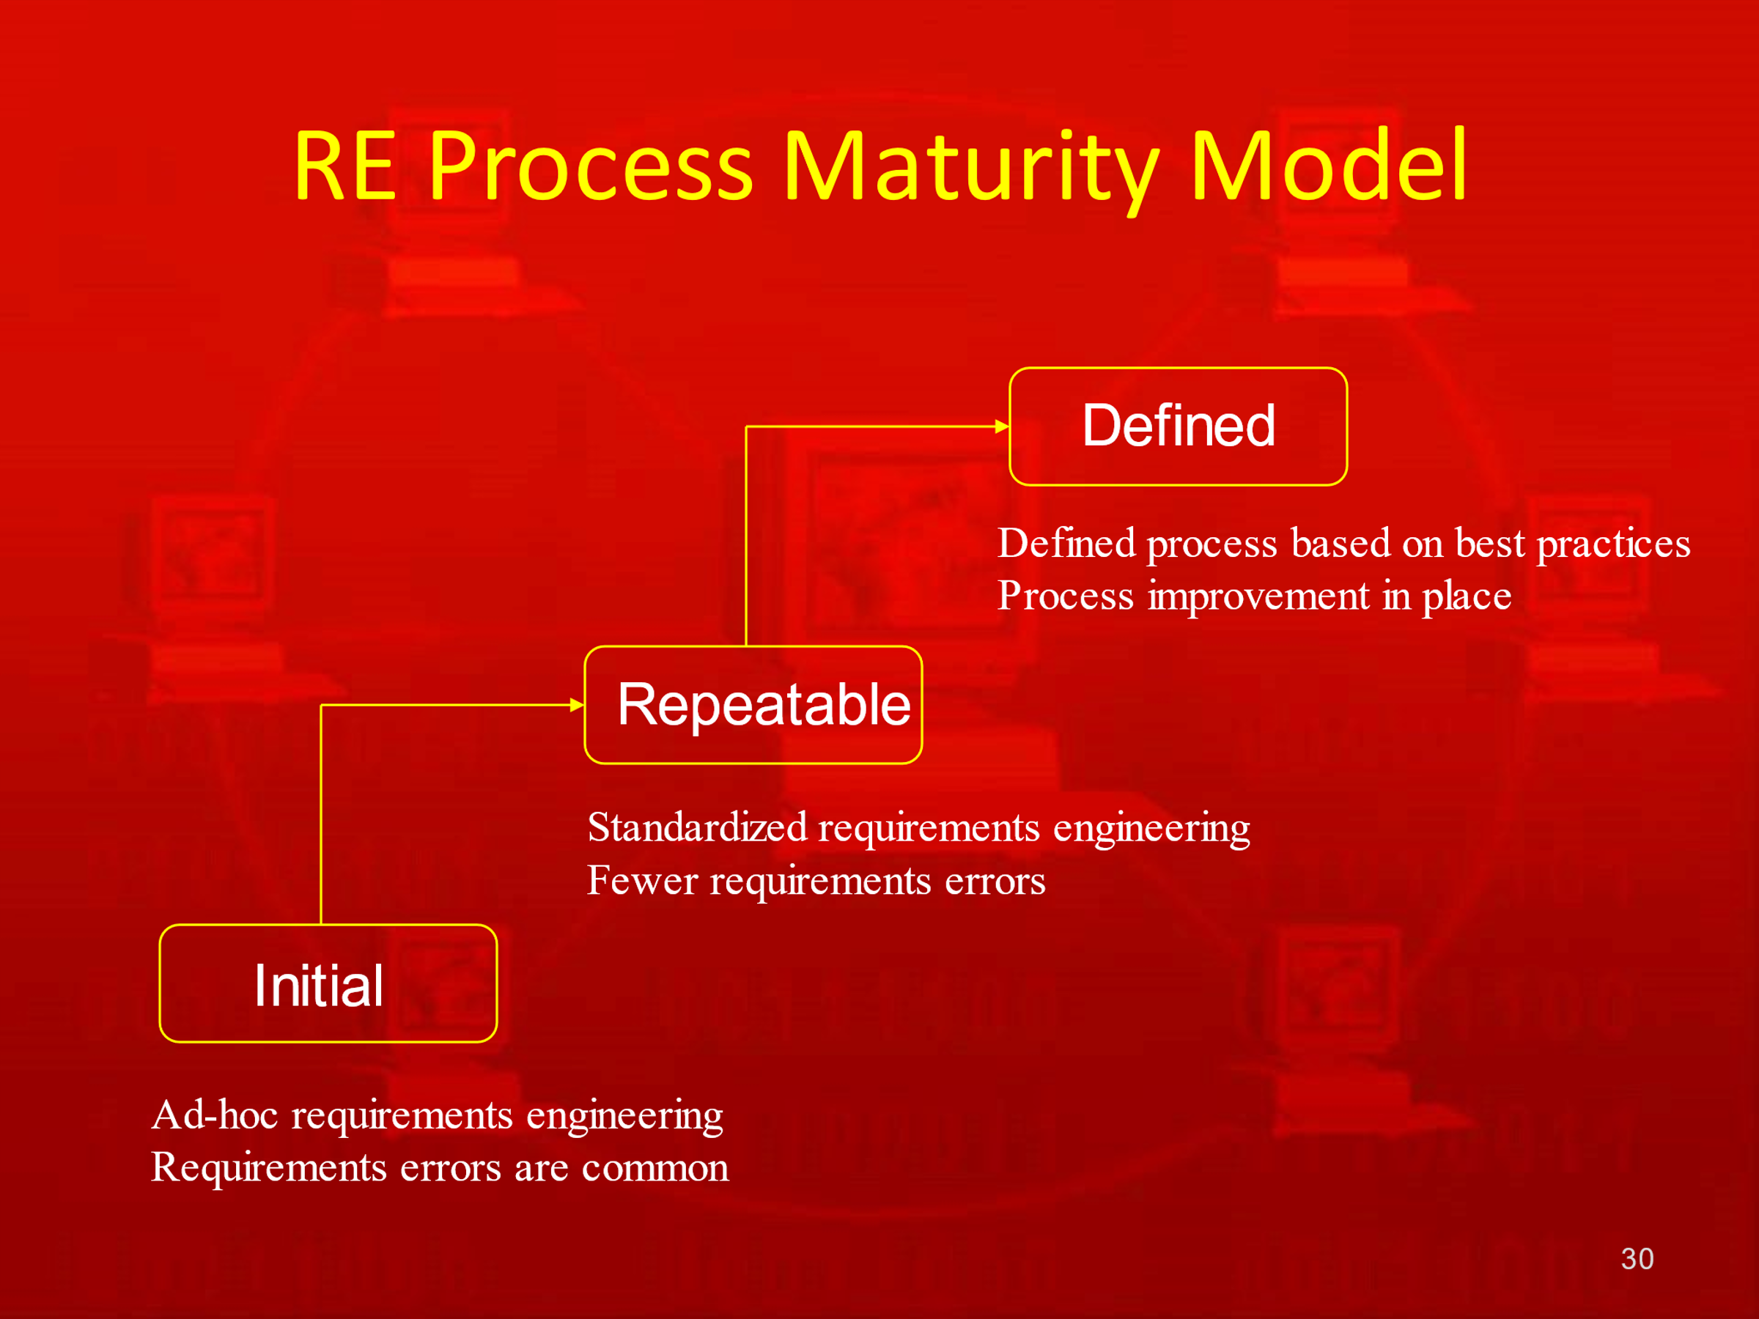

***Initial RE Process Maturity Level***

* There is no defined RE process.
* It suffers from requirements problems such as requirements volatility, unsatisfied stakeholders and high rework costs.
* It is dependent on individual skills and experience

***Repeatable RE Process Maturity Level***

* Defined standards for requirements documents, policies and procedures for requirements management

***Defined RE Process Maturity Level***

* Defined RE process based on good practices and techniques. Active process improvement process is in place

***Best Practices for RE Process Improvement***

* RE processes can be improved by the systematic introduction of best requirements engineering practices
* Each improvement cycle identifies best practice guidelines and works to introduce them in an organization
* Best practices will be discussed throughout the semester

***Requirements Engineering Costs***

* About fifteen percent (15%) of system development costs
* However, if the requirement’s engineering process is not executed properly, this cost can increase substantially

***Summary***

* Human, social and organizational factors are important influences on requirements engineering processes
* Requirements engineering process improvement is difficult and is best tackled in an incremental way
* Requirements engineering processes can be classified according to their degree of maturity